**Installing TestNG With Eclipse  
  
  
Step 1:**

* Launch Eclipse.
* On the menu bar, click Help.
* Choose the "Eclipse Marketplace..." option.

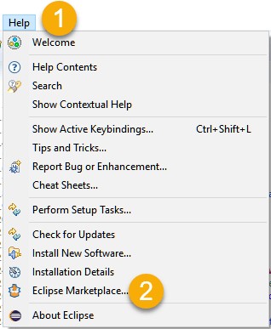

**Step 2:** In the Eclipse Marketplace dialog box, type TestNG in the search box and press the search button( magnifying glass) or press the enter key

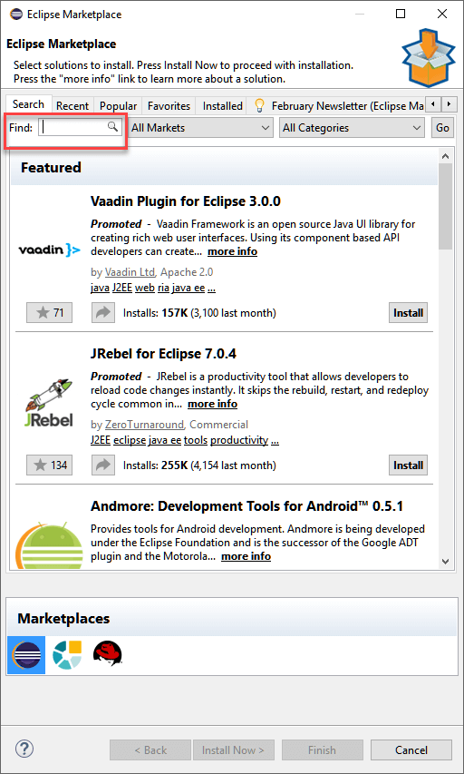

**Step 3:** Click Install

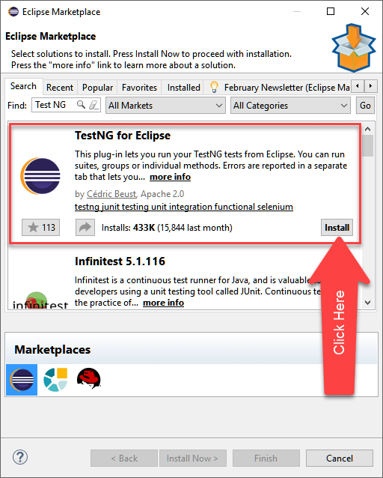

**Step 4:** A new window for feature selection will open, Do not change anything andclick on the confirm button

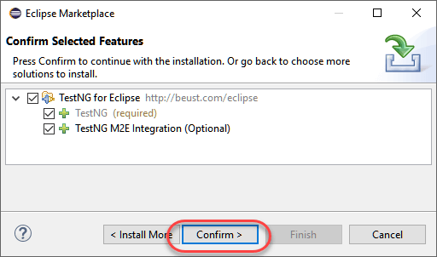

**Step 5:**

* Click Next again on the succeeding dialog box until you reach the License Agreement dialog.
* Click "I accept the terms of the license agreement" then click Finish.

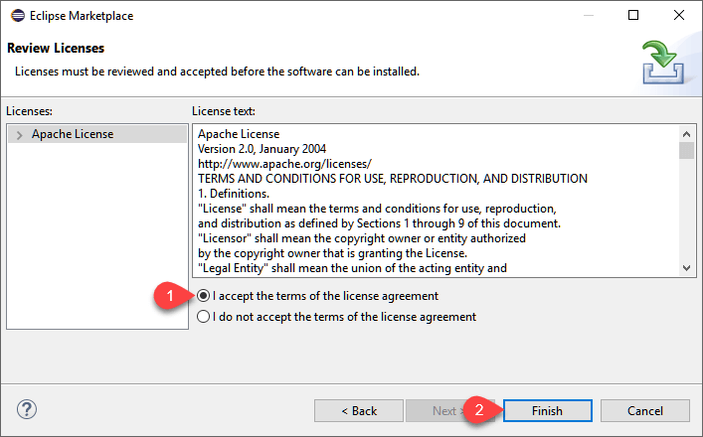

**Step 6:** If you encounter a Security warning, just click OK

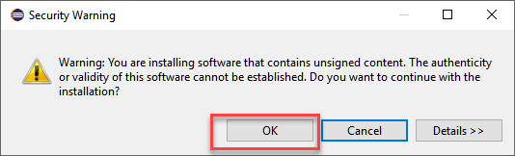

Wait for the installation to finish

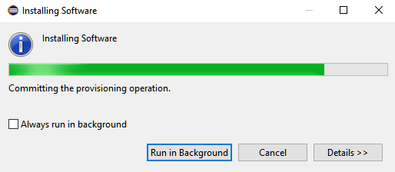

**Step 7:** When Eclipse prompts you for a restart, just click Yes.

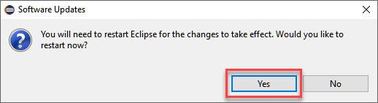

**Step 8:** After the restart, verify if TestNG was indeed successfully installed. Click Window > Preferences and see if TestNG is included on the Preferences list.

